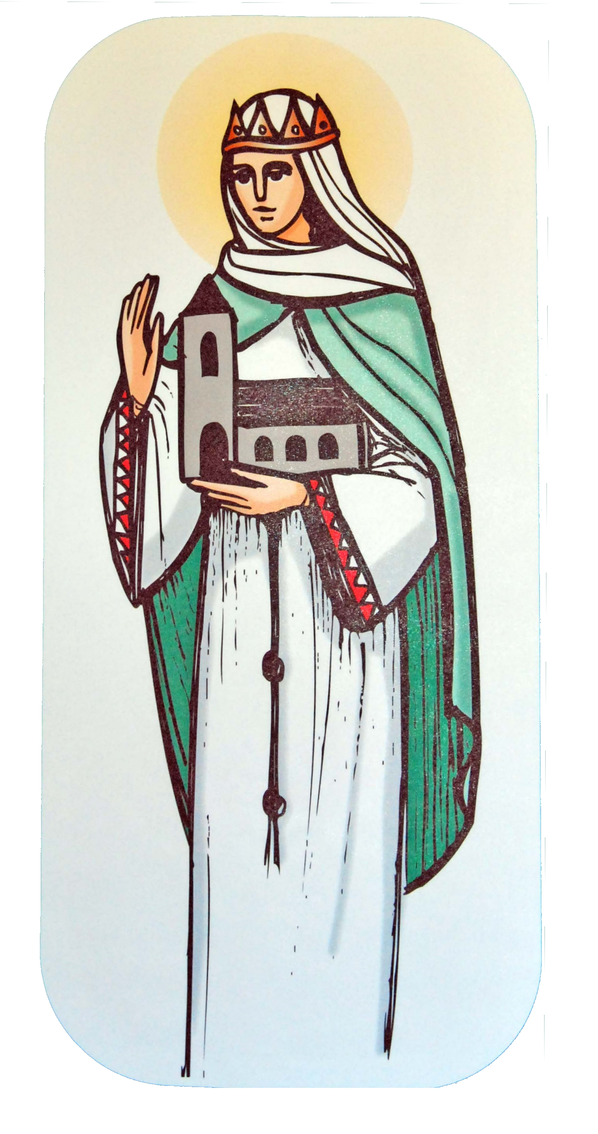

St Margaret of Scotland Catholic
Primary School

RE Curriculum Newsletter
Pentecost term
20th April – 21st July 2022

St Margaret of Scotland Catholic
Primary School
As we return to school after Easter the Church is still celebrating this great event. The focus of this term’s work in Religious Education is the role the Holy Spirit plays in our lives. We will be studying the three themes of Pentecost (Serving), Reconciliation (Inter-relating) and Universal Church (World). Each class will approach the themes through different topics.

Pentecost—Serving  YrR GOOD NEWS - Passing on the Good News of  Jesus  Yr1 HOLIDAYS AND HOLYDAYS - Pentecost: feast of  the Holy Spirit  Yr2 SPREAD THE WORD - Pentecost: a time to spread  the Good News  Yr3 ENERGY - Gifts of the Holy Spirit  Yr4 NEW LIFE - To hear and live the Easter message  Yr5 TRANSFORMATION - Celebration of the Spirit’s  transforming power  Yr6 WITNESSES - The Holy Spirit enables people to  become witnesses | At home  Talk about good news in your family and how you shared it.  Ask your child to tell you the story of Pentecost and the work of the Holy Spirit.
Reconciliation—Inter-relating  YrR FRIENDS - Friends of Jesus  Yr1 BEING SORRY - God helps us choose well  Yr2 RULES - Reasons for rules in the Christian family  Yr3 CHOICES - Importance of examination of  conscience  Yr4 BUILDING BRIDGES - Admitting wrong, being  reconciled with God and each other  Yr5 FREEDOM & RESPONSIBILITY – Commandments  enable Christians to be free & responsible  Yr6 HEALING - Sacrament of the Sick | At home  Talk together about times when you have forgiven and been forgiven.  Discuss the importance of saying sorry. Look for opportunities for forgiveness and reconciliation in the day to day life of the family.  
Universal Church – World  YrR OUR WORLD – God’s wonderful world  Yr 1 NEIGHBOURS – Neighbours share God’s world  Yr2 TREASURES – God’s treasure; the world  Yr3 SPECIAL PLACES – Holy places for Jesus and the  Christian community  Yr4 GOD’S PEOPLE – Different saints show people  what God is like  Yr5 STEWARDSHIP – The church is called to the  stewardship of Creation  Yr6 COMMON GOOD – Work of the worldwide  Christian family | At home  Together, look through a family scrapbook or photograph album of a visit to a place that is special for your family.  Look at a globe or an atlas. Find a special place and pray for the people of that country.  Discuss how we can look after our world and support our neighbours, near and far.
ISLAM
Pupils will study various aspects of Islam for one week. Ask them what they have been learning about.

Important dates for the Church this term: | May 26th The Ascension of the Lord.  June 5th Pentecost Sunday  June 12th The Most Holy Trinity  June 19th The Most Holy Body and Blood of Christ  June 24th The Most Sacred Heart of Jesus  June 29th SS. Peter and Paul, Apostles
The month of May is dedicated to Our Lady.

Try to take some time each day to say a decade of the Rosary with your children.
Hail Mary  Hail Mary full of Grace,  the Lord is with thee.  Blessed are thou among women  and blessed is the fruit of thy womb Jesus.  Holy Mary Mother of God,  pray for us sinners  now and at the hour of our death.  Amen. |  | Hail, Holy Queen  Hail, holy Queen, Mother of mercy,  hail, our life, our sweetness and our hope.  To thee do we cry, poor banished children of Eve:  to thee do we send up our sighs,  mourning and weeping in this vale of tears.  Turn then, most gracious Advocate,  thine eyes of mercy toward us,  and after this our exile,  show unto us  the blessed fruit of thy womb, Jesus,  O clement, O loving, O sweet Virgin Mary!  Amen.

